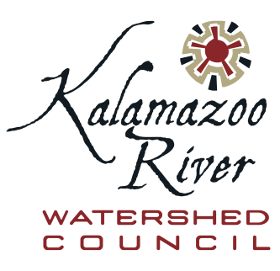  Board of Directors  Christine Kosmowski  Kenneth Kornheiser  Brian Huggett  David Heinicke  Donald Brown  Steven Kohler  Doug McLaughlin  Rachel Kluba  The Kalamazoo River Watershed Council is a public, non-profit 501(c)3 organization whose purpose is to work collaboratively with the community, government agencies, local officials and businesses to improve and protect the health of the Kalamazoo River, its tributaries, and its watershed. | Date: October 2, 2020  To: Jim Saric, USEPA Remedial Project Manager - Kalamazoo River Superfund Site  From: Kalamazoo River Watershed Council Board of Directors  Re: Request for information on potential bias in Kalamazoo River sediment/soil PCB results  Dear Mr. Saric,  The Kalamazoo River Watershed Council Board of Directors (the KRWC Board) has been informed by the Michigan Department of Environment, Great Lakes, and Energy (EGLE) of their concern about the potential that a significant amount of Kalamazoo River sediment/soil PCB concentration data being collected as part of the Kalamazoo River Superfund effort may be biased low, i.e., that reported concentrations are consistently less than the true concentration.  Members of the KRWC Board have reviewed a number of documents provided by EGLE to gain an initial understanding of the concern. These documents include the report titled “FIELDS Analysis of Replicate Lab Samples for [tPCB]” dated April 8, 2020 (the Fields report) in which sediment/soil samples were split and analyzed by multiple laboratories for PCBs, including two EPA labs, Pace Analytical Services, LLC (the Wood lab), and EGLE. Aroclor results from EPA’s ASB lab appear to be several times higher than results from Pace. The EPA CLP lab results also were higher, and were about the same as the EGLE PCB sum-of-congener results. The report further concludes that the Pace results are statistically significantly lower than results obtained by the other three labs.  Because there is potential that low-biased results could lead to remediation efforts that do not adequately address remediation goals, the KRWC Board would like to better understand the concern raised by EGLE. We request that you or someone else from USEPA with knowledge of this issue meet with the KRWC Board to provide USEPA’s understanding of the concern and an update on activities related to ensuring that the sediment/soil PCB data for the site are of known and adequate quality to support appropriate clean-up measures. Our questions include the following:  - What is the history, nature, and potential scope of the concern about potential low-bias in PCB results for Kalamazoo River sediment/soil PCB concentrations?  - Has there been a QA/QC review of the results in the FIELDS report, specifically to examine differences in extraction efficiencies for all four laboratories?  - What is the potential for the issue, if not addressed, to lead to remediation that does not truly meet required clean-up goals?  - What is the current status of the issue, and has EPA come to a conclusion regarding whether the Pace results are low-biased?  - What is the role of congener specific PCB data as compared to Aroclor data in Kalamazoo River sediment/soil remediation decisions?  Jim, would you be willing to attend the next KRWC Board of Directors meeting, scheduled for Monday October 19, 2020 at 5:30 pm Eastern Time, to address this concern? If that time is not available, we would be happy to consider alternative suggestions. We look forward to hearing from you.  Best regards,  KRWC Board of Directors  Sincerely,  Cheryl Vosburg – Executive Director  Kalamazoo River Watershed Council  1523 Riverview Drive, Suite A  Kalamazoo, MI 49004  (269) 447-1580

