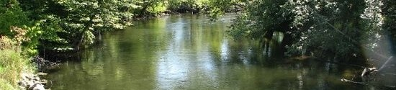

**KALAMAZOO RIVER WATERSHED COUNCIL Membership**

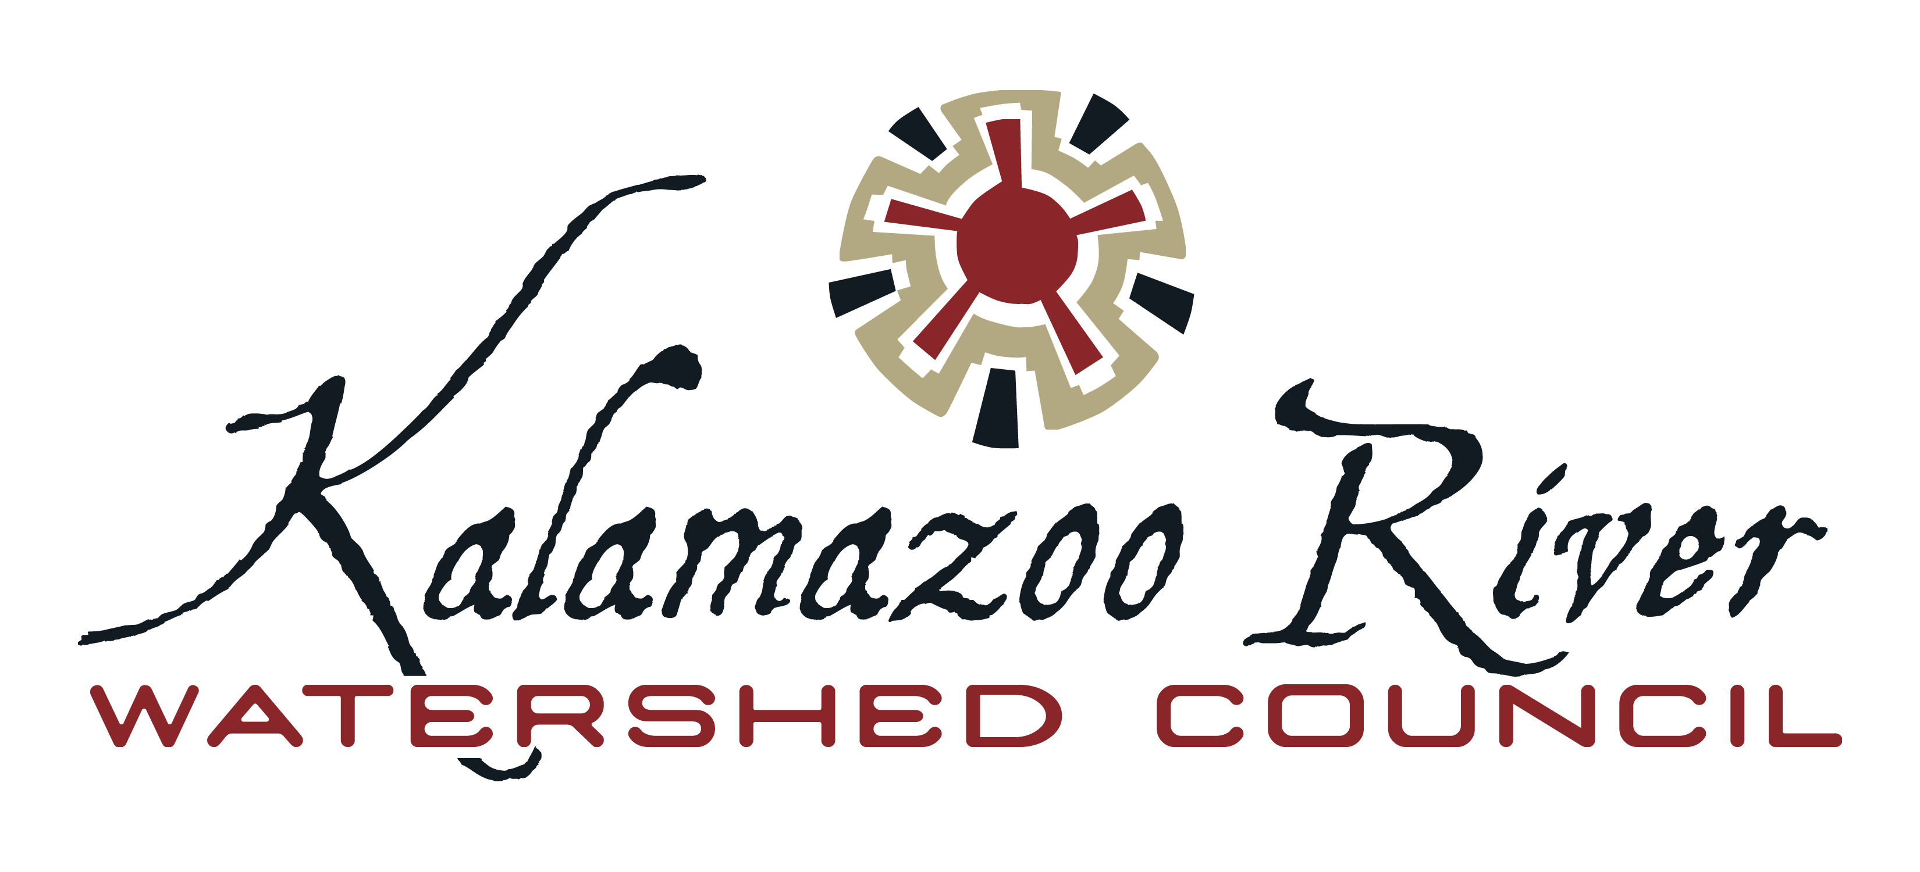

Already a member? Sign up as a monthly or quarterly sustaining member to make your membership renewal effortless.

**KRWC Partners**

CITIZENS

Soil & Water Conservation Districts

State & Federal Agencies

Resource Conservation & Development Councils County & Regional Governments

Tribal Entities

Watershed Groups

Lake Associations

Non-Profit Organizations

Corporations & Businesses

**Reoccurring Options**

□ One Time Only □ Monthly □ Yearly

KRWC offers automatic recurring options to make giving easier. **Monthly gifts help provide financial stability for our organization** and are a great way to increase your contribution without

feeling an additional pinch. They can be

as little or as much as you like and can

be stopped at any time.

**By the numbers…**

**8** counties in the watershed

**130** Miles long (KR Mainstem)

**178** Miles long (KR including the S. Branch)

**2020** sq. miles drain into the KR

**1863** ft3/sec is the median flow

1523 Riverview Dr.

Kalamazoo, MI 49004

269-447-1580

KRWC@kalamazooriver.org

**Become a Member**

**Kalamazooriver.org/membership**

**Account Type**

□ Individual

□ Business (*starts at River Steward level*)

**Membership Type**

□ Student/Senior - $15.00

□ Individual - $35.00

□ Family - $50.00

□ River Steward - $100.00

□ 178 River Mile Club - $178.00

□ Making Waves - $500.00

□ River Benefactor - $1,000.00

□ 2020 Sq. Mile Club - $2,020.00

□ Watershed Benefactor - $5,000.00

**As a member…**

Your contribution will be used to support the important programs that KRWC provides to individuals, organizations, and businesses within our watershed, making a difference in your community today and for future generations.

**Why support us?**

For more than 25 years the Kalamazoo River Watershed Council has provided opportunities for citizens, schools, governments, businesses and other community groups to get involved and active in ensuring a healthy Kalamazoo River through education, stewardship, and watershed management.

The KRWC is the recognized authority on and advocate for the waters of the Kalamazoo River Watershed**.**

**Together**

**we make a difference!**

About Us

The Kalamazoo River Watershed Council (KRWC) was established in 1993 as the Kalamazoo River Public Advisory Council, and operates as a 501(c)3 non-profit environmental organization.

Mission

To restore and protect the health of the Kalamazoo River, its tributaries, and its watershed by collaborating with the community, government agencies, local officials, and businesses.

**To Become a Member**

Visit us at

**Kalamazooriver.org/membership**